NOTOVA
User Manual
A complete guide to your books, from first launch to backup
Version 1.1 • June 2026
Local, self-hosted, encrypted double-entry accounting

Contents

1. Introduction
Notova is a lightweight, self-hosted double-entry accounting application that runs entirely on your own computer. There is no cloud account, no subscription, and no data ever leaves your machine. It is designed as a simple, private alternative to desktop accounting software for small businesses, rental owners, and anyone who wants straightforward books.
Everything is encrypted. Each set of books is stored as an encrypted file that can only be opened with its password. Even someone with direct access to your computer's files cannot read your data without that password.
What's new in 1.1: Amounts are now stored as exact whole cents (no rounding drift); the app keeps automatic, rotating encrypted backups; every transaction change is recorded in an edit history; passwords are stronger; and Notova now runs on a production-grade web server. None of this changes how you use the app day to day — your existing databases are upgraded automatically (and backed up first) the next time you open them.

Key features
- Double-entry accounting with a full chart of accounts (assets, liabilities, equity, income, expenses).
- Multiple databases, each with its own password and its own encryption.
- Amounts stored as exact integer cents, so totals always reconcile to the penny.
- Segment / class tracking, so you can break profit & loss down by property, department, project, or any grouping (now optional on every entry).
- Financial reports: Profit & Loss, Balance Sheet, Segment P&L, Cash Flow, Trial Balance, Statement of Equity, and Schedule E.
- Bank reconciliation, batch entry, and check-printing tools.
- Import transactions from CSV or Excel; export to CSV or Excel.
- Automatic rotating encrypted backups, plus on-demand backups you can store anywhere, with a built-in recovery helper.
- A complete edit history (audit log) of every transaction you create, change, or delete.

2. Installing and Starting the App

Requirements
- Python 3.11 or newer (free from python.org). During installation, check the box labelled “Add Python to PATH”.
- The app installs its helper packages the first time it runs: Flask, cryptography, and waitress (the production web server). openpyxl is optional and only needed for Excel import/export.

Starting Notova (Windows)
- Double-click START.bat (or your LAUNCH.bat shortcut).
- A black command window opens, checks dependencies, and starts the app.
- Open your web browser and go to http://localhost:5001.
Tip: Leave the black command window open while you work — it is the app. To stop Notova, close that window or press Ctrl+C inside it.
Note: Notova now serves on a production-grade server (waitress) and writes a log file, notova.log, next to the app. If anything ever goes wrong, that file is the first place to look.

3. Databases and Passwords
When you open the app, the first thing you see is a list of databases. A “database” is one complete set of books — for example one company, one property portfolio, or your personal finances. You can keep as many separate databases as you like, and each one has its own password.
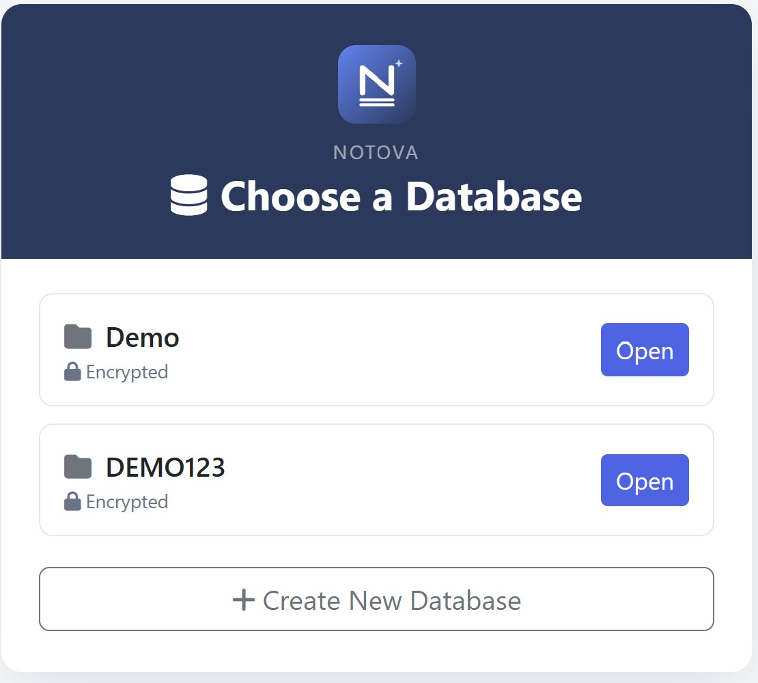
Figure 1. The database list — the first screen you see, showing each set of books and a button to create a new one

How passwords work
- Every database has its own password. There is no master password. Opening one database has no effect on the others.
- Your password is the encryption key. It is never stored anywhere. The app confirms it is correct simply by successfully decrypting your data.
- Passwords must be at least 8 characters. When you set one, a strength indicator helps you choose a strong password.
- After several wrong attempts, Notova briefly locks that database to slow down guessing. Wait the few seconds it shows, then try again.
- There is no recovery. If you forget a database's password, the data in that database cannot be recovered by anyone.
Important: Because your password encrypts the data, losing it means losing that database. There is no reset link, no backdoor, and no support line that can recover it. Keep a secure record of each database's password.

4. Creating Your First Database
- On the database list, click Create New Database.
- Enter a name (for example Smith Rentals).
- Choose a password and type it again to confirm. Use at least 8 characters; the strength meter will guide you.
- Click Create & Open. The app builds a fresh set of books — already including a standard chart of accounts — and opens it.
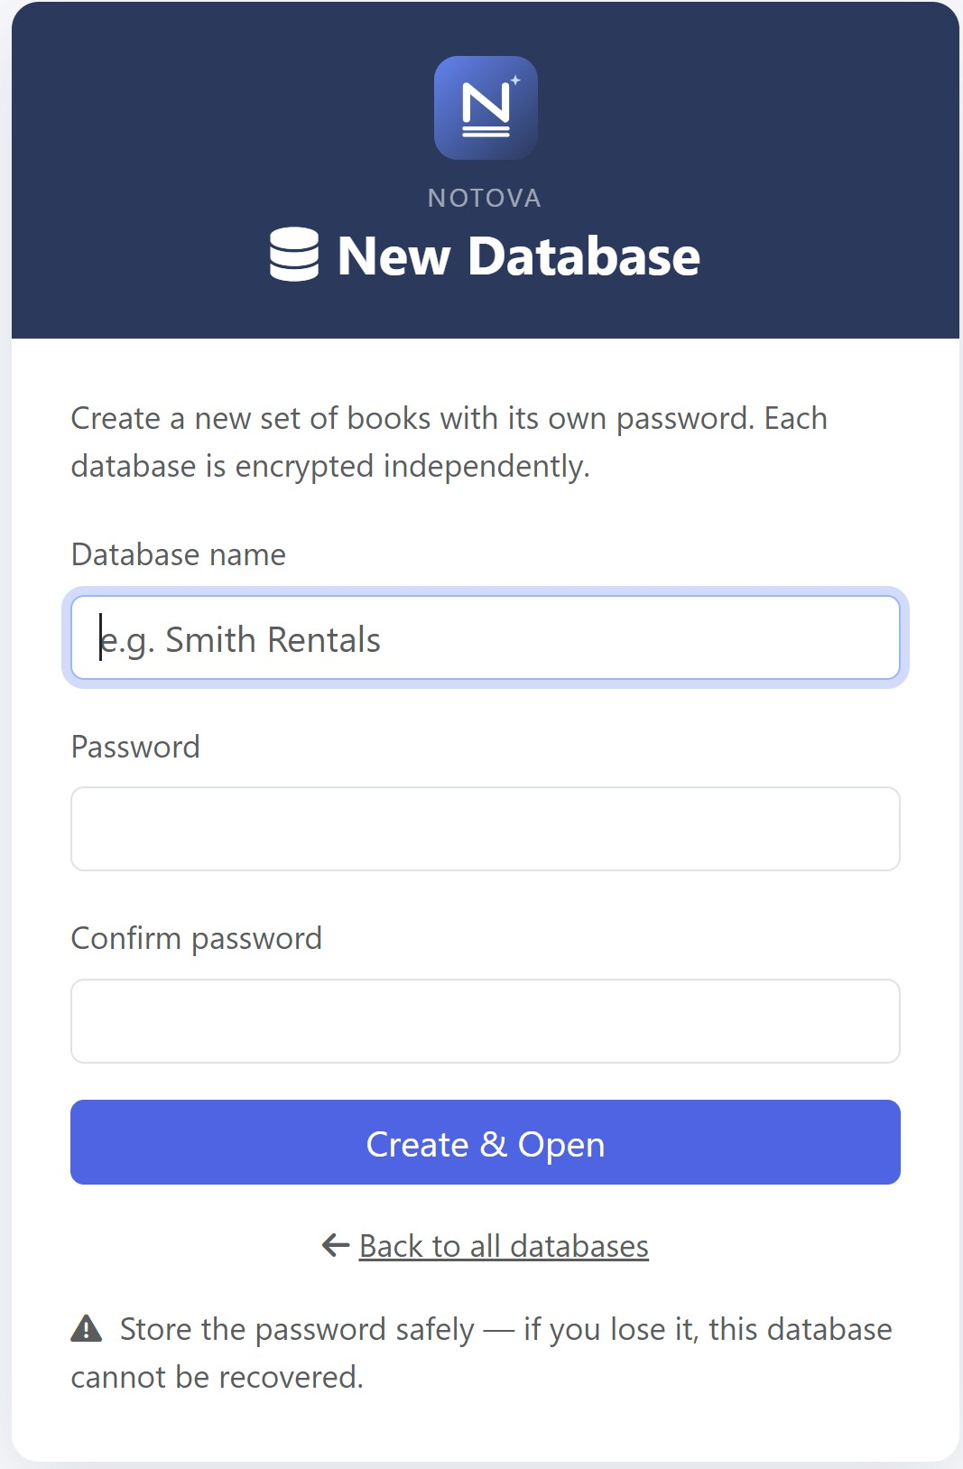
Figure 2. The New Database screen — name your books, set a password (with strength meter), and read the recovery warning shown just above the button

5. Opening, Locking, and Switching Databases

Opening a database
From the database list, click Open next to the database you want, then enter its password.
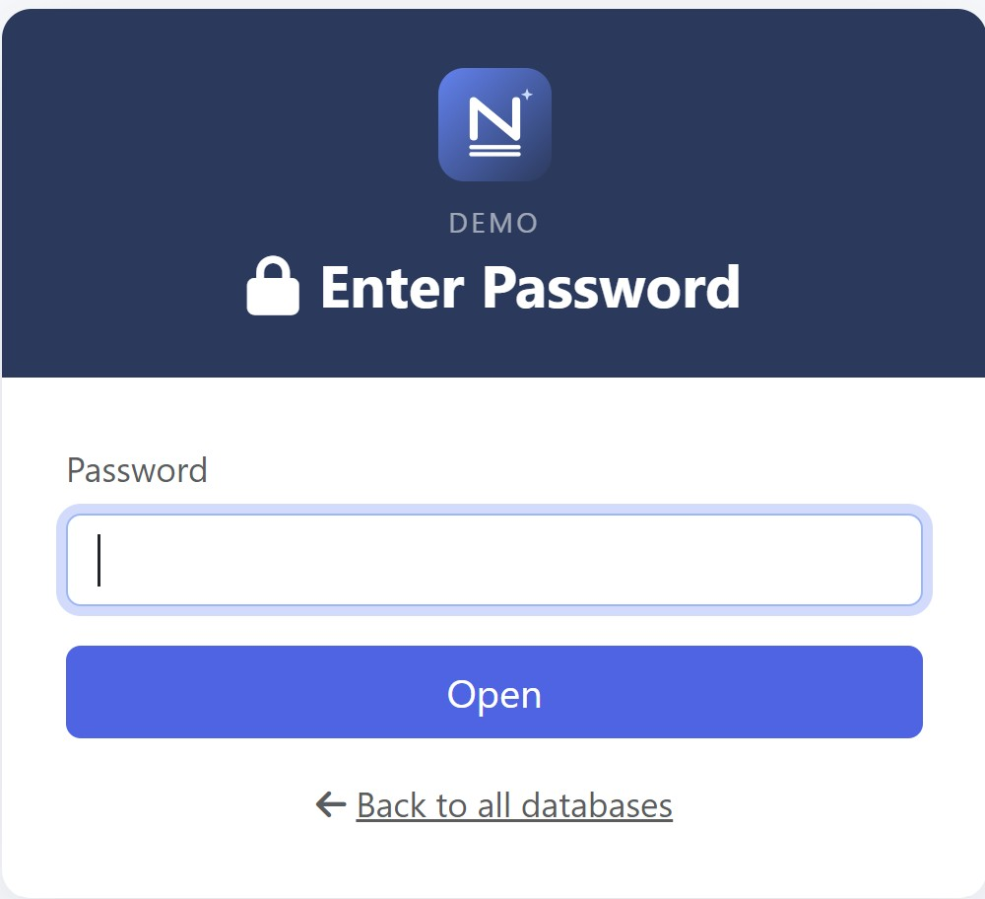
Figure 3. Entering a database's password to unlock it

Locking and switching
Inside the app, the sidebar has a Lock / Switch Database link. Clicking it re-encrypts your current database, clears it from memory, and returns you to the database list, where you can open a different one. Locking is also what you do when you step away from your computer.
One window at a time: A database can only be open in one running copy of Notova at a time. If you try to open a database that is already open elsewhere, Notova will tell you “This database is already open in another window.” This protects your books from two copies overwriting each other.

6. The Dashboard
After you open a database, you land on the Dashboard. It summarises the current year: income, expenses, net income, and a chart of monthly activity. The sidebar on the left is how you move between every part of the app, and its footer shows the app version you are running.
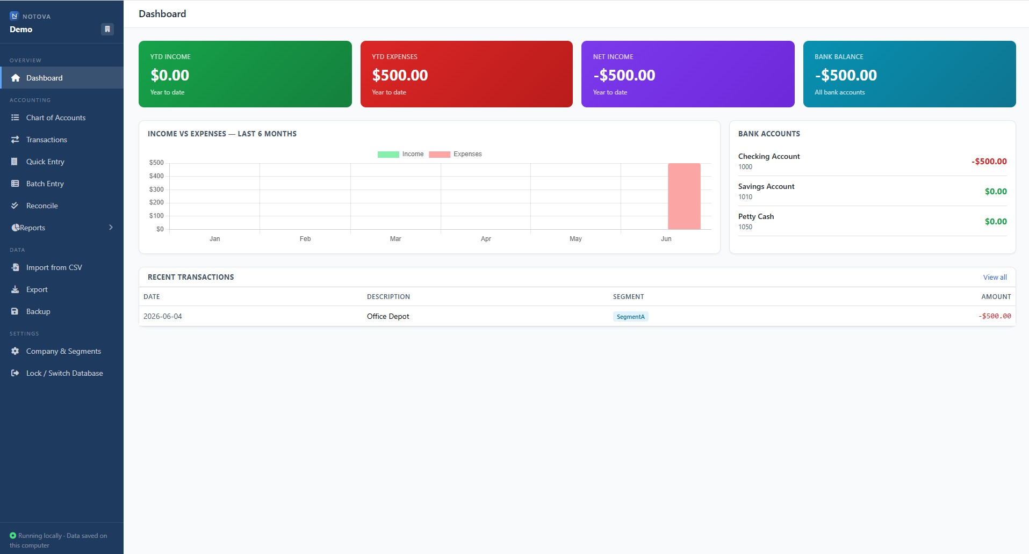
Figure 4. The Dashboard — year-to-date totals and the navigation sidebar

7. Chart of Accounts
The Chart of Accounts is the master list of categories your money flows through, grouped into Assets, Liabilities, Equity, Income, and Expenses. New databases come pre-loaded with a standard set of accounts to get you started; you can add, edit, or deactivate accounts at any time.
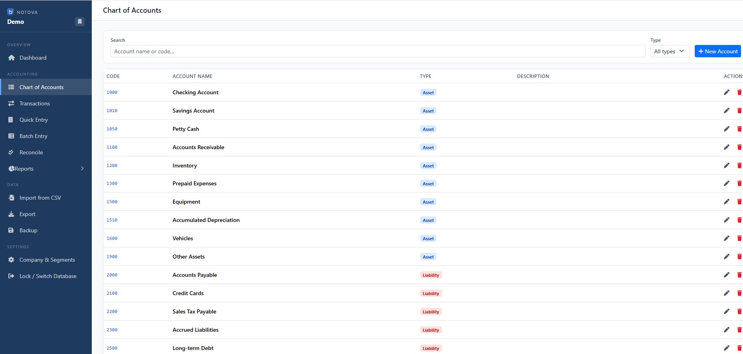
Figure 5. The Chart of Accounts
Tip — opening balances: To set a starting balance for a bank or other account, record a journal entry dated your start date that debits the account for the amount and credits an equity account (for example “Owner's Equity”). Don't use the Quick Expense or Deposit forms for this, because they post to income/expense rather than equity.

8. Recording Transactions
Notova uses double-entry accounting: every transaction has at least two lines, and total debits must equal total credits. Because amounts are kept as exact cents, an entry must balance to the penny — there is no rounding slack.

To record a transaction
- Open the Transactions screen and start a new entry.
- Enter the date, a description, and (optionally) a reference and a segment.
- Add lines, choosing an account for each and entering an amount in the Debit or Credit column.
- When debits equal credits, save the entry.
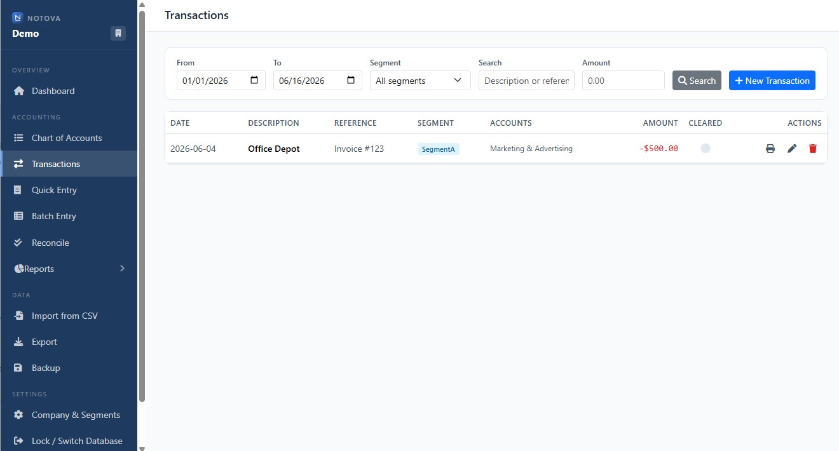
Figure 6. Recording a journal entry on the Transactions screen
Tip — finding entries: The Transactions list filters to the current year by default. If an entry doesn't appear (for example, imported history dated in a prior year), widen the Start date and click Search.

9. Quick Expense
Quick Expense is the fastest way to log an everyday cost without building a full journal entry by hand. Pick the date, the expense account, the account you paid from, an amount, and an optional segment, and the app records the balanced entry for you.
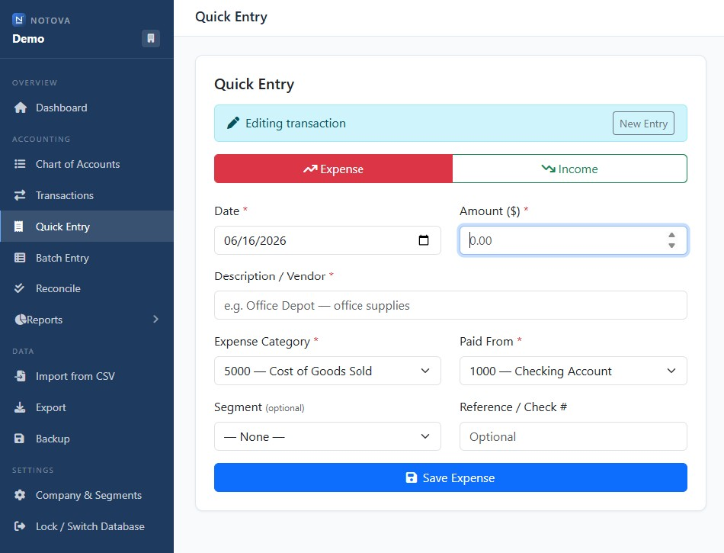
Figure 7. The Quick Expense form

10. Batch Entry
Batch Entry is a spreadsheet-style grid for posting many deposit-style lines at once against a single bank account — handy when entering a stack of rent receipts or a day's sales. Choose the bank account to deposit to and the date at the top, then fill one row per item: the account, an optional memo, an optional segment, and the amount. Click Save All to post them.
Segment is optional: Rows without a segment save normally; they simply aren't tagged for per-segment reporting. Only the account and a non-zero amount are required.

11. Segments
A segment is a label you attach to transactions so you can report on them as a group. Segments are completely up to you — they might be rental properties, departments, projects, locations, or clients. Once a transaction is tagged with a segment, it appears in the Segment P&L report and can be filtered throughout the app. Tagging is always optional.

Managing segments
Go to Company & Segments in the sidebar. There you can add a new segment (type a name and click Add Segment), or remove one you no longer use. Removing a segment does not change past transactions — it simply stops appearing in the dropdown lists.
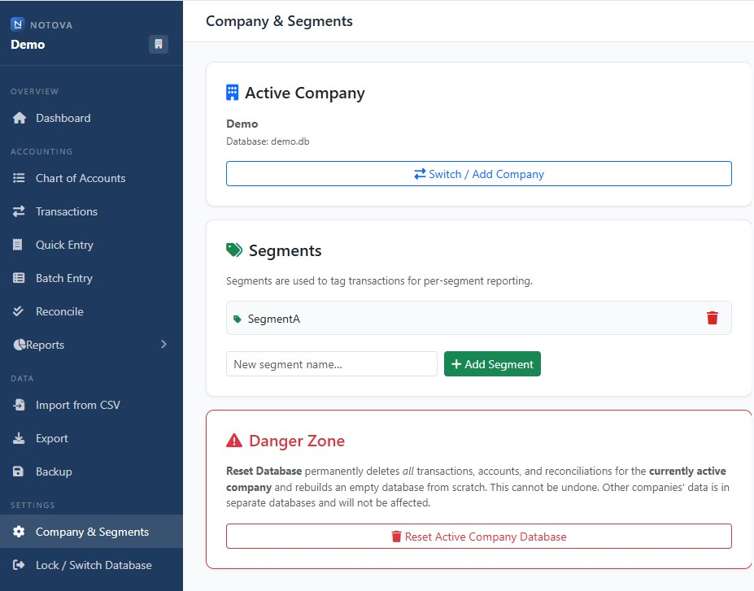
Figure 8. Managing segments under Company & Segments

12. Reports
Notova produces the standard financial statements, each for any date range you choose: Profit & Loss, Balance Sheet, Segment P&L, Cash Flow, Trial Balance, Statement of Equity, and Schedule E. Open a report from the Reports section of the sidebar. Because amounts are exact cents, the Trial Balance and Balance Sheet always tie out exactly.
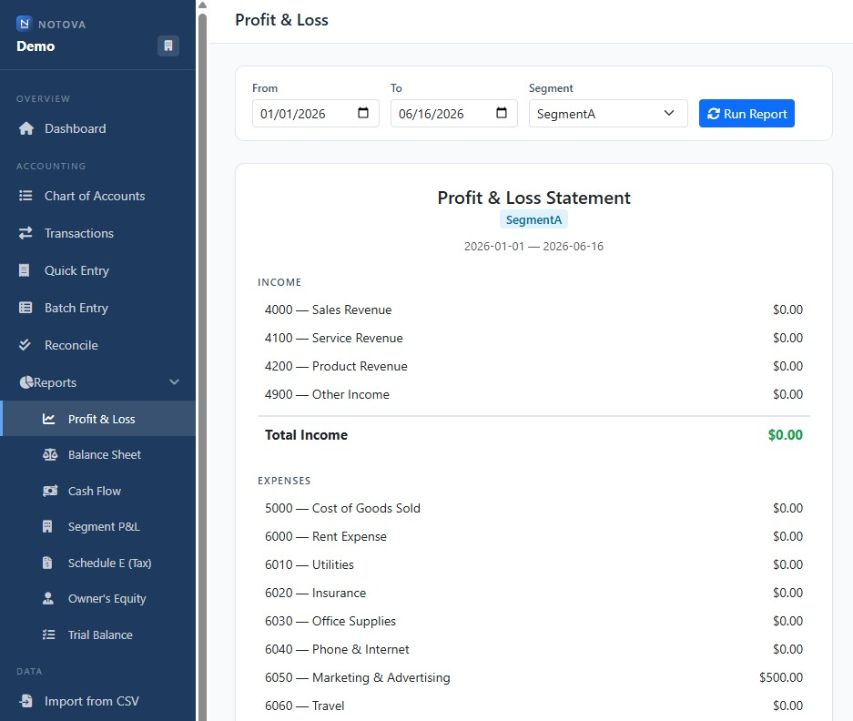
Figure 9. The Segment P&L report — one column per segment

13. Bank Reconciliation
Reconciliation is how you confirm that your books match your bank statement. Choose the account and the statement date, enter the statement's ending balance, and tick off the transactions that have cleared the bank. When the cleared balance matches the statement, the account is reconciled.
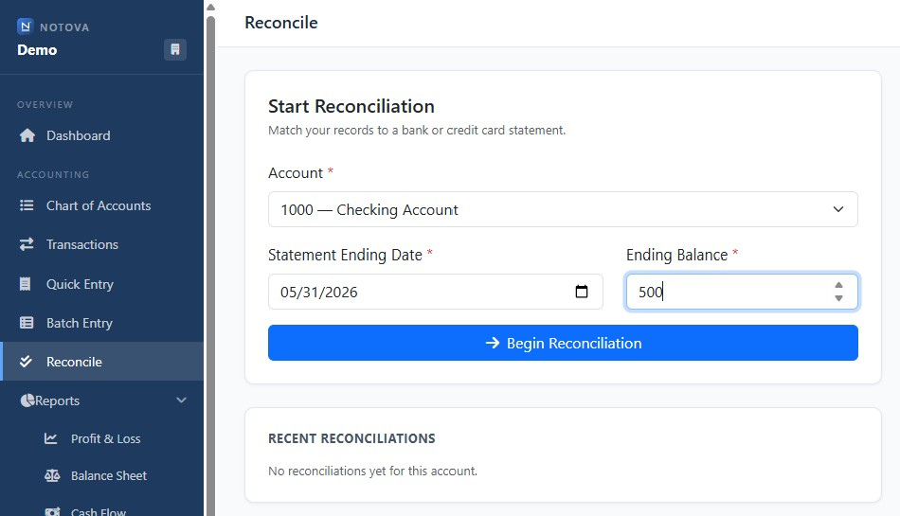
Figure 10. Reconciling an account against a bank statement

14. Printing Checks
The check-printing tool fills a standard check layout from a transaction — payee, amount (in figures and words), date, and memo — so you can print onto check stock. Notova is designed for standard voucher checks (one check with two attached stubs per page).
Aligning the print: Pre-printed check stock lines up a little differently on every printer, so each time you print a check you will need to “nudge” the layout (shift it up/down or left/right) so the text falls in the right places. Once you find the nudge amount that lines up on your printer, enter that same value every time.
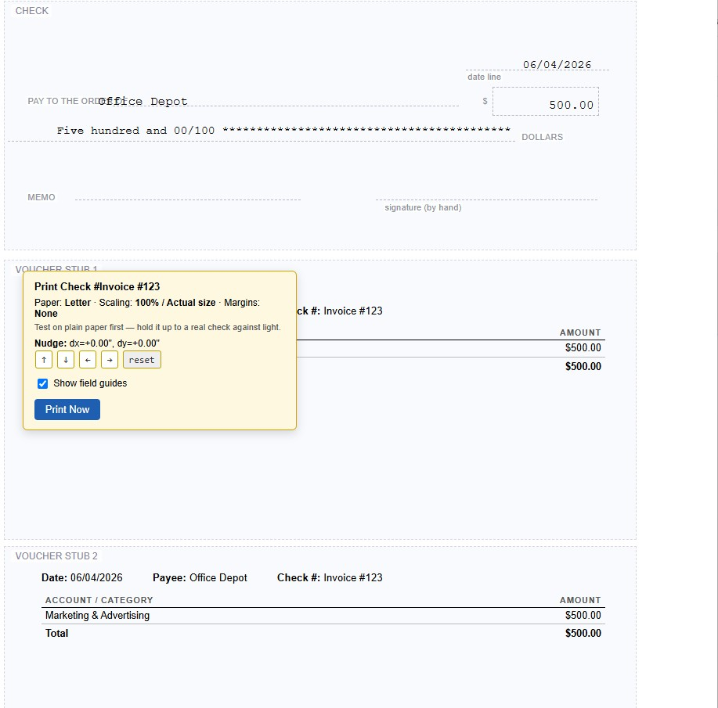
Figure 11. The check-printing screen

15. Importing from CSV
Notova can import transactions from a CSV (or Excel) file. Open Import from CSV in the sidebar and drop in your file. Notova reads it, lets you map each account or category in the file to a Notova account (creating new ones automatically when needed), shows a preview, and adds the entries to your current database. Before the import runs, Notova automatically takes a backup of your database, so you can always revert.
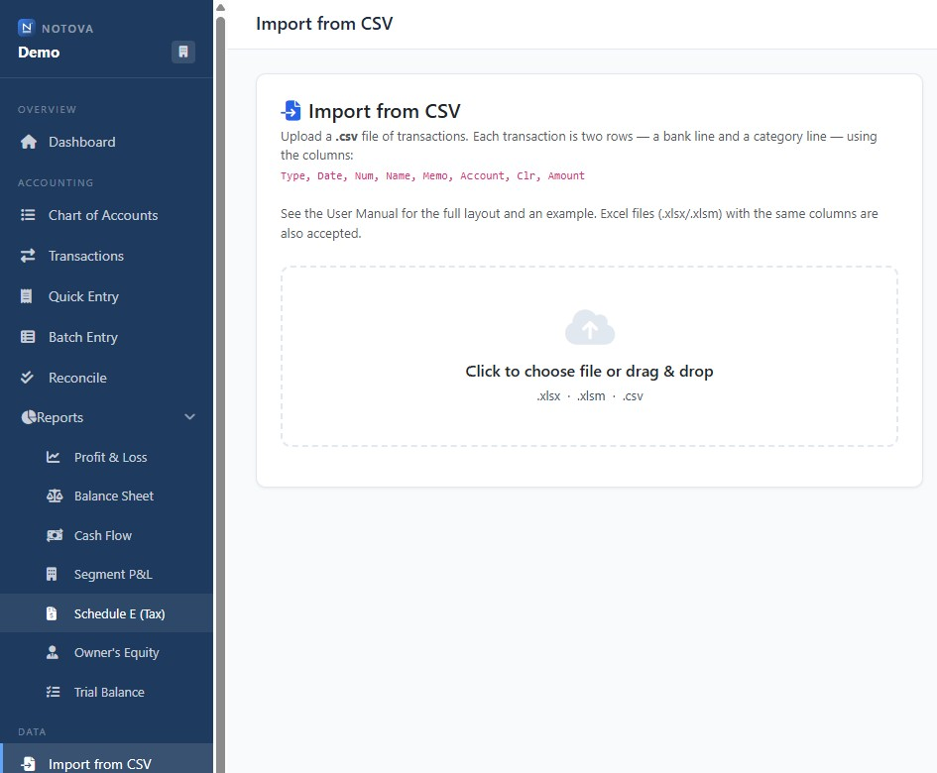
Figure 12. The Import from CSV screen

CSV layout
The file needs a header row with these columns, in this exact order:
Type, Date, Num, Name, Memo, Account, Clr, Amount
Each transaction is written as TWO consecutive rows — a bank line and a category line. Their Amounts are opposite and cancel to zero. For a check the bank line is negative and the expense line positive; for a deposit the bank line is positive and the income line negative.
Example (a check and a deposit):
Type,Date,Num,Name,Memo,Account,Clr,Amount
Check,01/15/2026,1001,City Power,Electric,Checking,X,-120.00
Check,01/15/2026,1001,City Power,Electric,Utilities,,120.00
Deposit,01/20/2026,,Acme Co,Invoice 100,Checking,X,500.00
Deposit,01/20/2026,,Acme Co,Invoice 100,Service Revenue,,-500.00
Tip: After importing, switch to the Transactions screen and widen the Start date if your imported entries are dated in a previous year — the list defaults to the current year, so older dates are hidden until you broaden the range. The Dashboard shows recent activity regardless of date.

16. Exporting Data
You can export your transactions or your chart of accounts to CSV at any time — useful for handing data to an accountant or for your own records. If Excel support is available, exports can also be produced as .xlsx workbooks. Exported files are plain (unencrypted), so store them carefully.

17. Backing Up and Restoring

Automatic backups
Notova protects your data without you having to think about it. Every time you open a database it saves a timestamped snapshot, and it takes one before any risky operation (an import, a database reset, or an automatic upgrade). These snapshots are kept in a folder named after your database with a .enc.backups extension, and the most recent 15 are retained. They are encrypted with your password, just like the live database.
In addition, every time Notova saves your database it immediately re-reads and decrypts the file to confirm the save is intact — so a bad write is caught at once rather than silently corrupting your books.

Making an on-demand backup
From the Backup option, choose a destination folder. Notova writes a .zip file containing your encrypted database, the app, and a small recovery helper. Because the database inside is encrypted, the backup is safe to copy to a USB drive or cloud folder — it still requires your password to open.

Restoring a backup
- Back into the app: copy the database's .enc file from the backup (or from a .enc.backups snapshot) into your Notova folder, then open it normally with its password.
- Without the app: the .zip backup includes restore_backup.py and a RESTORE_README.txt. Running the helper and entering your password decrypts the database to a plain file you can open in any SQLite tool.
Remember: A backup is only as recoverable as your password. The encrypted backup cannot be opened without it.

18. Edit History
Notova keeps an audit log: every time you create, change, or delete a transaction, it records what happened, when, and a before/after snapshot of the entry. The history is written together with the change itself, so it is always complete. This gives you an at-a-glance record of how your books evolved — useful for spotting an accidental edit or confirming when something was entered. Deleting a transaction preserves its details in the history rather than erasing them.

19. Security and Your Data
Notova is built to keep your financial data private:
- Encrypted at rest. Each database is stored as an AES-256-GCM encrypted file, with its key derived from your password using a deliberately slow, modern method (scrypt) that resists guessing. On disk it is unreadable without your password.
- Decrypted only in memory. While a database is open, its data lives in your computer's memory, not as a readable file on disk. Locking the database or closing the app clears it.
- Independent databases. Each set of books has its own password and key, so one password never exposes another database.
- Local only. Notova listens only on your own computer (127.0.0.1) and rejects requests from other web pages, so a site open in your browser cannot reach into the app. There is no cloud, no account, and no telemetry.
What this does not protect against: While a database is open and you are logged in, the data is necessarily readable by the app. Lock the database when you step away, keep your passwords private, and remember that a lost password means lost data.

20. Troubleshooting
Symptom | What to do
Transactions list shows only some (or no) entries | It defaults to the current year. Widen the Start date and click Search. The Dashboard shows recent items regardless of date.
“This database is already open in another window” | Another running copy of Notova has it open. Close the other window (or reboot for a clean slate), then try again.
“Incorrect password” on a known-good database | You may have selected the wrong database — each has its own password. Re-check which one you opened.
“Too many attempts” when unlocking | A safety lock-out after repeated wrong tries. Wait the few seconds shown, then enter the correct password.
First open after updating is slow | On the first unlock after an update, Notova upgrades and re-secures the database (after backing it up). This happens once per database.
Browser shows old data / port in use | A stale copy still holds the address. Close all Notova windows (or reboot) and relaunch.
Forgotten password | Unrecoverable by design — there is no reset. Restore from a backup whose password you know.

21. Quick Reference
Action | How
Start the app | Double-click START.bat, then open http://localhost:5001
Open a database | Pick it on the list and enter its password
Lock / switch | Sidebar → Lock / Switch Database
New transaction | Transactions → new entry (debits must equal credits)
Quick cost | Quick Expense → date, expense, paid-from, amount
See older entries | Transactions → widen the Start date → Search
Back up | Backup → choose a folder (also automatic on every open)
Check version | Sidebar footer, or visit /api/version
Notova User Manual · Version 1.1 · June 2026

